

**Faculty of engineering - Shoubra**

**Benha University**

# Research Article / Research Project / Literature Review

in fulfillment of the requirements of

|  |  |
| --- | --- |
| **Department** | **Engineering mathematics and physics** |
| **Division** |  |
| **Academic Year** | **2019-2020** |
| **Course name** | **computer** |
| **Course code** | **ECE001** |

## Title: -

Operating systems

|  |  |  |  |
| --- | --- | --- | --- |
|  | Name | Edu mail | B.N |
| 1 | مصطفي فرغلي السيد عفيفي | Mustafa196025@feng.bu.edu.eg | 16 |

**Approved by:**

|  |  |
| --- | --- |
| Examiners committee | Signature |
| Dr.Ahmed Bayoumi | 1 |
| Dr.Shady Elmashad | 2 |
| Dr.Abdelhamid Attaby | 3 |

**Application brief:**   
What is an Operating System?

An Operating system (OS) is software which deals as an interface between the end user and computer hardware. Every computer should have at least one OS to run other programs. An application likes Chrome, MS Word, Games, etc. needs some environment in which it will run and perform its task. The operating systems help you to communicate with the computer without knowing how to speak the computer's language. It is not possible for the user to use any computer or mobile device without having an operating system.

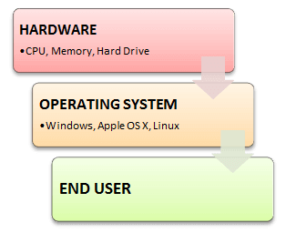

**The importance of operating system:**

Operating system is the most critical software installed on a computer. Not only does an OS act as the administrator of many computer processes, but it also allows users to harness the power of the various sound, graphics and memory assets within the computer's hardware infrastructure. For the vast majority of users today, a computer would be useless if it did not include some form of an operating system.

Popular technology culture has introduced most of us to one of the two major operating systems in use: macOS and the Windows operating system. Although these systems function in different ways, the services they provide to users are relatively similar. With that in mind, taking the time to understand the importance of an OS can help ensure that you have the data you need to find the right computer for your needs.

Operating system is system software, the computer work. We can say that an operating system (OS) is software and hardware interfaces for your behavior. It contains not only speak the language for hardware drivers, but also give you with a very specific graphical user interface (GUI) to control the computer. An operating system can also be used as an interface (from the hardware) to other software. Like Windows or Linux or a Mac OS operating system provides a complex operating system services, but also has inch Solitaire, paint, Messenger build applications, are applied.

Application software is software that you install your operating system. It includes procedures; just let you use your computer things. These applications are run on various operating systems. These include like your word processing program, spreadsheet things, e-mail client, Web browser, games and many other programs, such as most of Microsoft’s Office suite is written in the Mac and Windows versions, but you still have to have your correct version of the operating system.

When an ISP’s preliminary consideration is to look at the sort of access required. Some ISP only provides dial-up access, is the slowest type of connection. If you want cable service, you will check with your local cable provider to see if it is to provide cable access. For DSL service, you may have several options – or it may be DSL is not yet available in your area. Typically, this can be remedied by telephone calls to improve the local telephone company lines.

Each ISP has its own privacy policy and service (TOS) contract terms that users must agree to before subscription will be accepted. Privacy policy say the company will not with the personal information collected at the time of registration. Name, address, credit card number, is usually required. Privacy policy and under what conditions should also be your personal information with third parties may be, government officials or others to share state. Terms of service contract use of this service. For example, dial-up access is often sold “unlimited access”, but this is not literally. General limit per month dial-up accounts 250-400 hours, depending on ISP. The real unlimited access (to your computer and actively connected to the Internet 24 / 7) are called dedicated access. Most DSL or cable subscriptions allow dedicated access.

**Screenshots:**

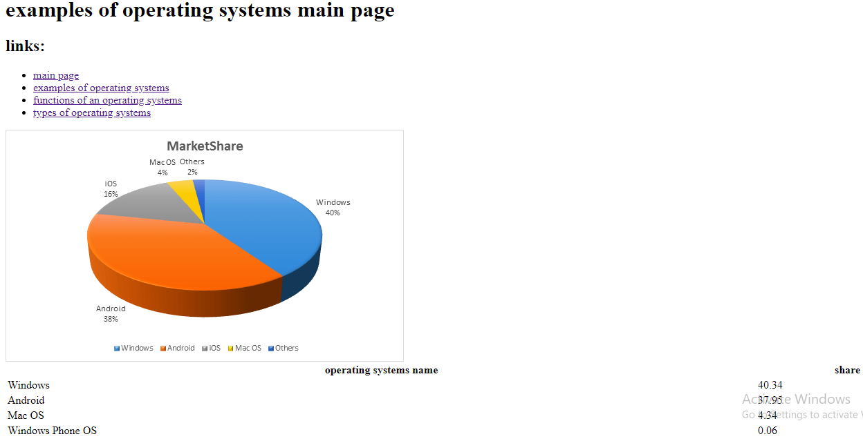

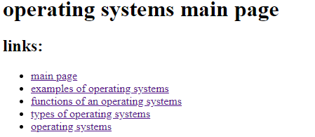

**Source code:**



